La URL del archive en sharepoint lo obtiene de Copy Shortcut

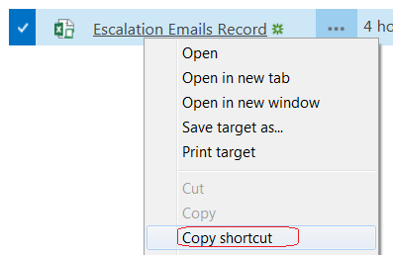

Private void DownloadFile()

{

WebClient client = null;

try

{

client = new WebClient();

client.Credentials = CredentialCache.DefaultNetworkCredentials;

string filename = "Escalation Emails Record.xlsm";

string URL = "https://cvgsharepoint/sites/netappblr/NetApp-Blr/Shared%20Documents/Escalation%20Tracker/Escalation%20Emails%20Record.xlsm";

client.DownloadFile(URL, filename);

}

catch (Exception ex)

{

}

finally

{

if (client != null)

client.Dispose();

}

}

Lo baja en el mismo directorio donde corre aplicacion

Cree table y lea archivo

string Conn = "Provider=Microsoft.ACE.OLEDB.12.0;Data Source=C\\temp\sss.xlsm;Extended Properties=Excel 8.0; **Password**= s3curity1!";

OleDbConnection connExcel = new OleDbConnection(Conn);

System.Data.Common.DbDataReader dr = null;

try

{

connExcel.Open();

OleDbCommand command = new OleDbCommand("Select * from [Raw Data$] WHERE JOB_FAMILY ='ADMIN' ", connExcel);

dr = command.ExecuteReader();

}

catch(Exception es)

{

}

connExcel.Close();